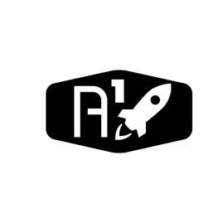

DESIGN DOCUMENT

Area : Converse Engine

Category: Feed (Piping)

TEAM: Propulsion

Nyameaama Gambrah